Lab 4: Refraction of Light
Student’s name: __________________________
Objectives:

- Verify Snell’s Law and use it to identify an unknown material.
- Determine how intensity changes when light is refracted.

Background: How does light bend?

Light travels at different speeds in different media. As light passes at an angle from one medium to another, it changes direction at the boundary between the two media. The index of refraction of a medium, n, is the ratio of the speed of light in a vacuum, c, to its speed in the substance, v.

$$n = \frac{c}{v}$$

When light enters a medium with a higher index of refraction than the medium it is leaving, it bends toward the normal. When light enters a medium with a lower index of refraction than the medium it is leaving, it bends away from the normal. This change of direction of light at the boundary of two media is called refraction.
For any light that is traveling from one medium of index of refraction $n_{1}$, at angle of incidence $θ_{1}$, to another medium of index of refraction $n_{2}$, Snell’s law of refraction describes the angle of refraction, $θ_{2}$, experienced by the light.

$$n_{1}sinθ_{1}=n_{2}sinθ_{2}$$

In this lab, you confirm Snell’s Law by taking simple measurements. You will also investigate what happens to the intensity of the light as it refracts, and you will determine the refractive index of two unknown materials.

For this lab, you are required to submit a short lab report, containing the answers to all questions in Parts One, Two. Your submission simply needs to contain the answers and data tables. You may hand write your answers and take photos of your work, or you may use Word, Google Docs etc. You must submit a single document on Canvas

For this lab you will be using an online simulator from the University of Colorado Boulder. Click on the link below to get to the website:

https://phet.colorado.edu/sims/html/bending-light/latest/bending-light_en.html

Once you get there, click on ‘Intro’.

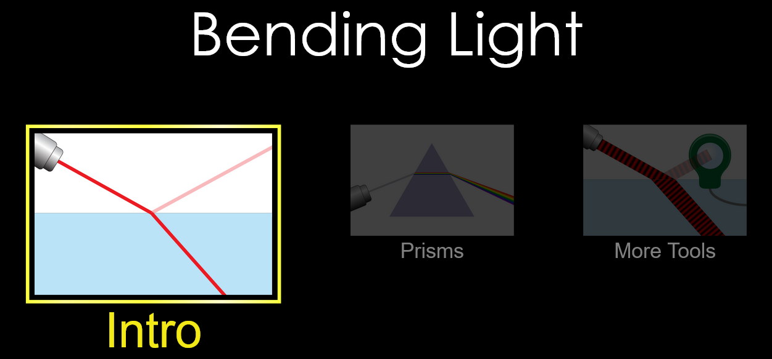

Part 1: Confirming Snell’s Law

- When the simulator window opens, you should notice a laser pointing at a 45º angle downwards to the right. Look to the right of the window and notice that the two information boxes are explaining the mediums that are shown on the screen.
What are the two mediums on the simulator window currently?

………………………………………………………………………………………………………

- Click on the RED button on the laser. What two things does the light do as it hits the surface of the water?

……………………………………………………………………………………………………
- Change the material of the second medium (where the refracted ray is) to Glass using the menu box on the bottom right.
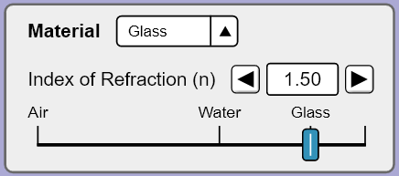
Choose the protractor tool and place the protractor over the vertical normal line so that the dotted line runs straight through zero. Set the laser (click on it and move it when the green arrows appear) to an angle of incidence $θ_{1}$, at 30°. Recall: angles are always measured from the Normal.
Ignore the reflected ray (the ray that remains in air). Using the protractor, measure the angle of refraction $θ_{2}$, of the laser and record this in Table 1.
Repeat these steps for 4 more angles of incidence (see values $θ_{1}$ in table below). Record the results in Table 1 (or create a table of your own).
Note that

$$θ_{1} (°)$$ | $$θ_{2} (°)$$ | $$sinθ_{1}$$ | $$sinθ_{2}$$ | $$n_{2}=\frac{sinθ_{1}}{sinθ_{2}}$$
30
40
50
60
70
Table 1
- Calculate sin$θ_{1}$ and sin$θ_{2}$ and plug the values on the third and four columns of table 1. If you don’t have a calculator use the following link to find those quantities: Sin_Calculator. After those values have been obtained, the index of refraction of medium 2 can be calculated as the ratio $n_{2}=sinθ_{1}/sinθ_{2}$. Keep your results to 2 decimals. Notice that the index of refraction of air (medium 1) is $n_{1}=1$

- Compare the values for index of refraction of glass for each trial (values in last column). Is there good agreement between them? Would you conclude that index of refraction is a constant for a given medium?
……………………………………………………………………………………………………
……………………………………………………………………………………………………
……………………………………………………………………………………………………
……………………………………………………………………………………………………
……………………………………………………………………………………………………
- Determine the average value of $n_{2}$ from your results.

average $n_{2}$ = ……………………….

- Compare your calculated $n_{2}$ with the given index of refraction of the glass (1.50). Do they agree? Explain why it does or doesn’t.
……………………………………………………………………………………………………
……………………………………………………………………………………………………
……………………………………………………………………………………………………
……………………………………………………………………………………………………
……………………………………………………………………………………………………

Part 2: Refractive Index of a Mystery Material
- Change the material of the first (incident) medium to ‘Mystery A’ and the second medium to Glass $(n_{2} = 1.50$).
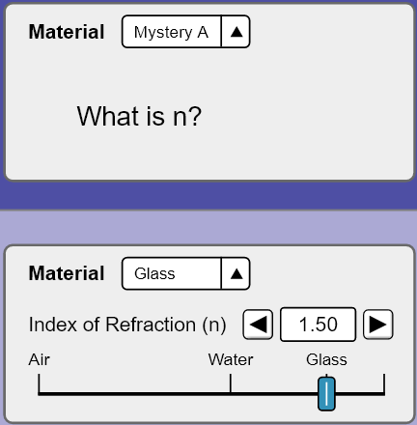
- Change the incident angle of the laser $θ_{1}$ (values on the table below)and record the sets of results for $θ_{2}$ for each angle of incidence. Calculate $sinθ_{1}$ and $sinθ_{2}$ and their ratio to fill the third, four, and fifth columns in table 3. Note that $n_{2} = 1.50$

$$θ_{1} (°)$$ | $$θ_{2} (°)$$ | $$sinθ_{1}$$ | $$sinθ_{2}$$ | $$n_{1}=n_{2}\frac{sinθ_{2}}{sinθ_{1}}$$
10
15
20
25
30
Table 2

- Find the average of the values in the fifth column (last column) and record it below,

$n_{1}=$refractive index of medium 1 = ……………………

- Using the table below, determine what the mystery material might be:
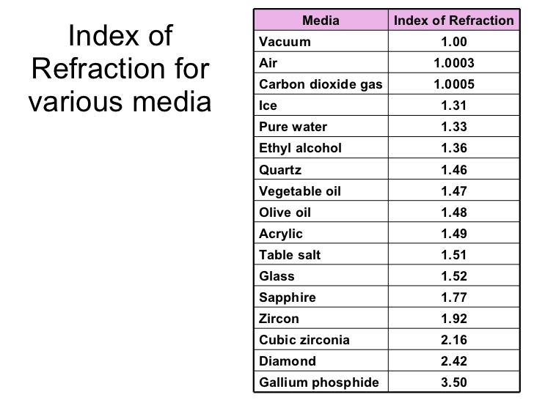

mystery material = ……………………...
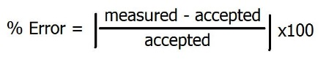
- Find the percent error of your observed value (average value obtained at (c)) using the identified index of refraction as your accepted value. This is an indication as to how ‘good’ your result is. Show your working.

percent error = …………………………….....

